Meeting 4/28

Upcoming:
- Divakar trying to host a desi game night in collab with SABG in May
  - Exact date and details still in the works
- Todo:
  - Cochairs to come up with list of tournament-able games/event ideas

Membership Updates:
- Decided to increase membership prices next quarter
  - Exact amount to be determined based on what the calendar looks like
  - Currently thinking of increasing all memberships by $10
- Considering adding 2 quarter membership at end of Fall Quarter
  - Then replace it with 1 quarter membership at end of Winter quarter

Events:
- Come up with event calendar before end of Spring quarter
- Add events to game club on booth groups so people can see what is coming up in advance
- Aim to have a min of 1 tournament every quarter
- Keep a scoreboard of most active members
  - Additional points for members who win their games (maybe not for chill game nights?)
  - Maintain on excel/website
    - Can we add slackbot to keep track of score?
- Norm - If we do not get enough registrations for the game we want to play, refund all those who paid and call your friends/non-members to fill up the required spots
- Charge $5 for weekly game nights - members will be refunded, non-members will not be refunded

List of tournament ideas:
- Chess
- Jenga
- Poker (high demand)
  - Winter
- Catan (can be done virtually)
  - Fall
  - Replicate Namit’s tournament style
- Codenames (can be done virtually)
- Mario Kart
  - Big game party day
  - Venue: One of the MPP area buildings
  - Fall
- Smash tournament
  - Winter - Lunch hour
  - Classroom
  - Miral has game

List of event ideas:
- Activate
  - Spring (maybe Winter if we want)
- The Game Show Room
  - Game show with your friends
  - Miral to test out how it goes
- Escape Rooms
  - 6 tickets already booked (1 room) by Aakash
  - 2 out of 3 quarters
- Snakes & Lattes trips
  - 1 a quarter
- Murder Mystery Night (Flagship event)
  - Make it a networking event type thing but with a theme of murder mystery
  - Winter quarter (potentially Spring?)
    - Will compete with Winter gala
  - Do on a Friday / Saturday night
  - Up to 100 people
  - Gleacher
    - In-home catering
  - Todo:
    - Figure out how long the murder mystery part is
    - Email Jessica to get it venue reserved
- Chill game nights (casual/familiar games)
  - Once a week
- Novel game nights (new/less known games)
  - Once a month
  - Build game collection
    - Give the option to rent games out
  - Cochair learns the game and teaches to those who join
  - Todo:
    - Figure out what demand is?
- Board Games Arena Event
  - Once a week
  - Miral and Aakash have accounts
  - Virtual event
  - Asynchronous games
    - Can be played over a week
- Trivia nights
  - Once every 2 weeks
  - Can be hosted virtually - jackbox games (Divakar has trivia game)
- Beginning of the year kickoff: Game Room at the Chicago Athletic Association, Barcade, reserve room at one of the Booth buildings. It would be good to have a larger, social event towards the beginning of the year so members can see each other’s faces!

Merch:

Like this logo for merch. Some changes to be made:
- Try using maroon for “Booth Gaming”
- Replace the heart with spade
- Replace top right quadrant with a game controller

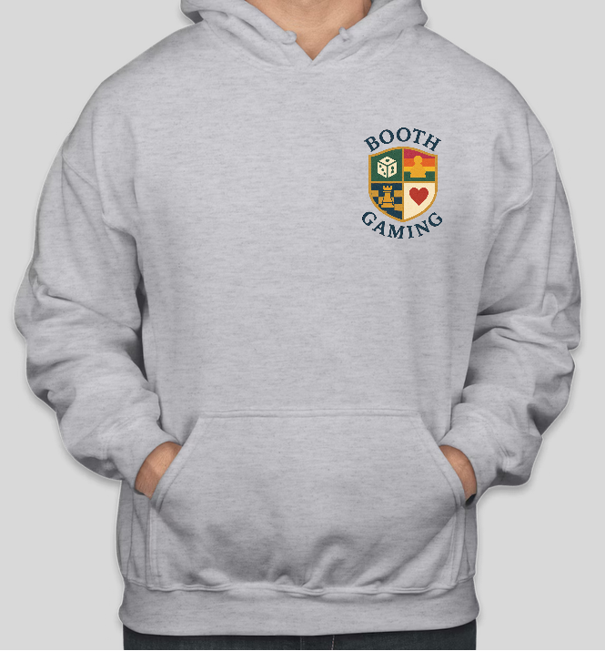
- Looks good. Add “Chicago Booth” logo to arm

Like the phoenix design too
Change symbols underneath
Look at crewnecks

Additional:
- End of quarter member with most points on scoreboard gets a price
  - Can be Booth Gaming merch
  - Can be them buying a game up to a certain $ value
- Cochairs should have a monthly meeting at the very least
  - Can try for biweekly meeting to begin with
- Make an inventory of games

